Project Development Phase
Model Performance Test

Date | 12 February 2026
Team ID | LTVIP2026TMIDS90862
Project Name | Prosperity Prognosticator: Machine Learning for Startup Success Prediction
Maximum Marks | 10 Marks

Model Performance Testing:
Project team shall fill the following information in model performance testing template.
S.No. | Parameter | Values | Screenshot
 | Metrics | Classification Model:  Confusion Matrix - ,  Accuray Score- 0.76  Classification Report -  precision recall f1-score support  0 0.68 0.60 0.64 65  1 0.80 0.85 0.82 120  accuracy 0.76 185  macro avg 0.74 0.72 0.73 185  weighted avg 0.76 0.76 0.76 185 | 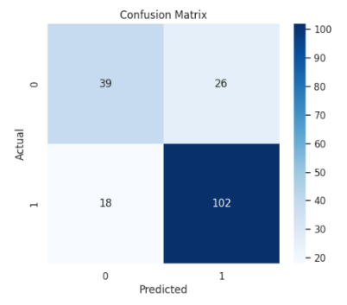
 | ROC_Curve | Auc Score – 0. 80974358974358 | 